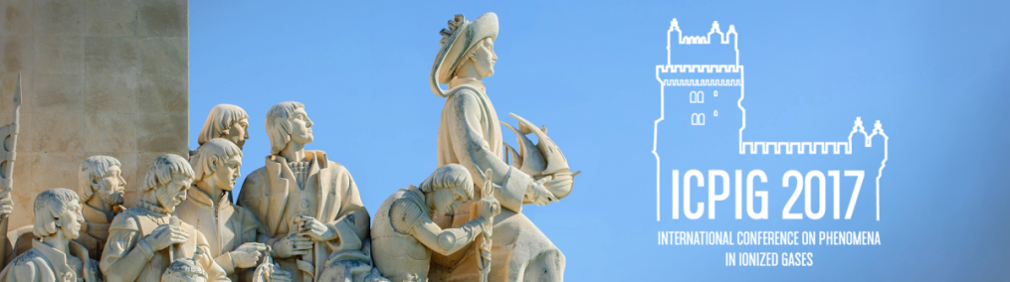
ICPIG 2017 @ ESTORIL / LISBON (PORTUGAL) - 9 – 14 July 2017
APPLICATION FORM FOR FINANCIAL SUPPPORT

Last name: Click here to enter text.
First name: Click here to enter text.
Institution: Click here to enter text.
Age: Click here to enter text.
Gender: Click here to enter text.
Nationality: Click here to enter text.
Position: Choose an item.
Postal address: Click here to enter text.
Phone: Click here to enter text.
E-mail: Click here to enter text.

Justification for application to financial support
Click here to enter text.

My contribution is intended for topic Choose an item.
Type of contribution: Choose an item.
Other sources of support applied for: Click here to enter text.
Signature of the applicant
For PhD students, name and signature of the thesis supervisor is required

Please fill in and sign this form, sending it by e-mail (with subject ICPIG2017 - LOC Financial Support) to pcanabela@tecnico.ulisboa.pt.
Join a copy of the contribution submitted and a recommendation letter from the applicant's supervisor (in the case of students).

The deadline for applications for financial support is March 3 2017

This financial support is granted through sponsorship of the International Union of Pure and Applied Physics

